**Patient Case Similarity**

# Nikshap R 20211COM0098

# Suraj H C 20211COM0094

# Hemanth V 20211COM0091

# Syed Inaam 20211COM0009

**Abstract** — This project develops a web-based healthcare analytics application aimed at enhancing the decision-making capabilities of healthcare professionals through AI-driven analytics. It features a role-based access control system tailored for doctors and researchers, integrating cutting-edge web technologies to provide real-time insights and predictive analytics. The application architecture leverages React for the frontend, Node.js and Express for the backend, with AI functionalities powered by Python-based libraries like TensorFlow or PyTorch. Key components include secure authentication, role-specific dashboards, and responsive design, all containerized with Docker and orchestrated by Kubernetes to ensure scalability and manageability.

**Keywords** - Healthcare Analytics, AI-driven Insights, Role-Based Access, Real-Time Predictive Analytics, Web Application Development, Containerization, Responsive Design

# INTRODUCTION

# In the evolving landscape of healthcare, the integration of advanced analytics and artificial intelligence (AI) has become pivotal for enhancing clinical decision-making and improving patient outcomes. The healthcare analytics web application described herein is designed to harness these technologies to provide a comprehensive tool for healthcare professionals. Utilizing a robust, web-based platform, this application offers tailored functionalities for distinct user roles—namely doctors and researchers—allowing them to access, analyze, and interpret healthcare data in real-time. Built with React and Node.js, and leveraging machine learning capabilities through Python, the system not only facilitates the immediate application of clinical insights but also ensures a responsive and intuitive user experience. Key features include role-based access control, AI-driven analytics for real-time and predictive insights, and a scalable architecture using Docker and Kubernetes for efficient deployment and management. This project aims to bridge the gap between complex data analytics and everyday clinical practices, thereby enabling healthcare providers to make more informed decisions and deliver better patient care.

**A NEW PARADIGM IN PATIENT SIMILARITY CASE**

**Real-time, AI-driven Clinical Decision Support** refers to the use of artificial intelligence technologies to analyze healthcare data instantly and provide actionable insights directly to healthcare professionals. This approach leverages continuous data flow and advanced algorithms to facilitate immediate clinical decision-making.

* **Key Components of the New Paradigm:**
* **Real-time Data Analysis:** Utilization of AI to process and analyze patient data as it is being collected, offering up-to-the-minute insights that are essential for urgent medical decision-making.
* **Predictive Capabilities:** Application of machine learning models to predict patient outcomes, identify risk factors, and suggest preventative measures based on current and historical data.
* **Role-Based Access Control:** Customization of data accessibility based on the user’s role within the healthcare system to ensure that all personnel have the appropriate level of information relevant to their specific functions.
* **Adaptive and Responsive Care:** The ability of the system to adapt to new data inputs and modify patient care plans accordingly, enhancing the responsiveness of medical interventions.
* **Implications of the New Paradigm:**
* **Enhanced Decision-Making:** Provides doctors and healthcare professionals with powerful tools to make well-informed decisions quickly, drastically improving patient care and treatment outcomes.
* **Proactive Healthcare Management:** Shifts the healthcare approach from reactive to proactive, focusing on early detection and prevention based on real-time data and trends.
* **Efficiency in Healthcare Delivery:** Improves operational efficiency by reducing the time spent on data analysis and increasing the accuracy of medical diagnoses and interventions.
* **Technological Foundations:**
* **Artificial Intelligence and Machine Learning:** Core technologies that drive the analytics and decision-support capabilities of the platform, enabling sophisticated data processing and interpretation.
* **Web-based Platform:** Ensures accessibility and scalability, providing a centralized interface for managing and visualizing data insights across various devices and locations.
* **Future Prospects:**
* **Expansion of AI Applications:** Continued development and integration of AI into various facets of healthcare, expanding from clinical support to operational management and personalized medicine.
* **Increased Data Integration:** Enhanced ability to integrate and analyze diverse data types from multiple sources, leading to more comprehensive patient profiles and treatment strategies.

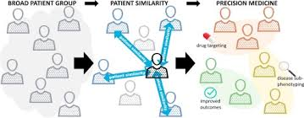

**Fig 1**

# BENEFITS

**1. Improved Patient Outcomes:**

* **Enhanced Diagnostic Accuracy:** AI algorithms can analyze complex datasets to identify patterns that may be missed by human eyes, leading to more accurate diagnoses.
* **Personalized Treatment Plans:** Leveraging real-time data allows for the customization of treatment plans tailored to the individual needs of each patient, increasing the effectiveness of interventions.
* **Early Disease Detection:** AI can predict disease progression and potentially harmful events before they occur, enabling preventative measures that can significantly improve patient prognosis.

**2. Increased Efficiency:**

* **Reduced Time-to-Treatment:** Instant data processing and insight generation expedite the decision-making process, reducing the time from diagnosis to treatment initiation.
* **Automation of Routine Tasks:** AI can automate mundane tasks such as data entry, analysis, and reporting, freeing up medical staff to focus on more critical aspects of patient care.
* **Optimized Resource Allocation:** Predictive analytics can help manage hospital resources more effectively, from staffing and bed allocation to the management of medical supplies.

**3. Enhanced Decision-Making:**

* **Data-Driven Insights:** Provides healthcare professionals with actionable insights derived from a comprehensive analysis of real-time and historical data.
* **Risk Assessment:** AI models can assess patient risk for various conditions and outcomes, allowing healthcare providers to prioritize care based on individual risk profiles.
* **Clinical Decision Support:** Offers support tools that help clinicians make informed decisions by providing them with clinical data, potential risks, and recommended actions.

**4. Cost Reduction:**

* **Preventative Care:** By predicting potential health issues before they become severe, AI-driven systems reduce the need for expensive emergency care and lengthy hospital stays.
* **Improved Treatment Efficacy:** Personalized treatments often lead to better health outcomes, reducing the need for further medical intervention and associated costs.
* **Efficient Use of Imaging and Tests:** AI can suggest when patients need to undergo imaging or other tests, avoiding unnecessary procedures that do not contribute to patient care.

**5. Advancements in Medical Research:**

* **New Insights from Data:** AI can uncover new patterns and correlations in large datasets that human researchers might overlook, leading to new medical hypotheses and treatment options.
* **Clinical Trial Recruitment:** AI can help identify suitable candidates for clinical trials more quickly and accurately, accelerating research and the development of new drugs and therapies.
* **Longitudinal Studies:** AI systems can efficiently handle and analyze longitudinal data across patient populations, offering insights into long-term health trends and outcomes.

**6. Improved Accessibility and Inclusivity:**

* **Remote Monitoring and Care:** AI-driven platforms can facilitate remote health monitoring and telemedicine, making healthcare more accessible to people in remote or underserved regions.
* **Multilingual Support:** AI systems can provide multilingual support, breaking down language barriers in healthcare and making information more accessible to diverse patient populations.

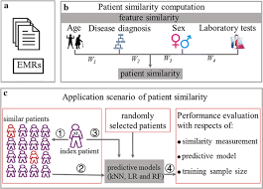

**Fig 2**

# PRACTICAL EXAMPLE

// App.tsx

import React from 'react';

import { BrowserRouter as Router, Route, Switch } from 'react-router-dom';

import Home from './Home';

import Navigations from './Navigations';

function App() {

return (

<Router>

<div>

<Navigations />

<Switch>

<Route path="/" exact component={Home} />

{/* Additional routes can be added here */}

</Switch>

</div>

</Router>

);

}

// main.tsx

import React from 'react';

import ReactDOM from 'react-dom/client';

import App from './App';

import './index.css'; // Assuming some global styles in index.css

const root = ReactDOM.createRoot(document.getElementById('root'));

root.render(

<React.StrictMode>

<App />

</React.StrictMode>

);

// Home.tsx

import React from 'react';

function Home() {

return (

<div>

<h1>Welcome to the Healthcare Analytics Dashboard</h1>

<p>This is the main dashboard of the application where you can view analytics and insights.</p>

</div>

);

}

export default Home;

// Navigations.tsx

import React from 'react';

import { Link } from 'react-router-dom';

function Navigations() {

return (

<nav>

<ul>

<li><Link to="/">Home</Link></li>

{/* Additional navigation links can be added here */}

</ul>

</nav>

);

}

export default Navigations;

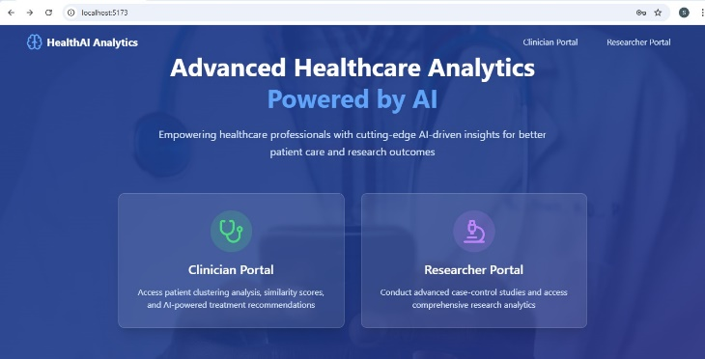

**Fig 3**

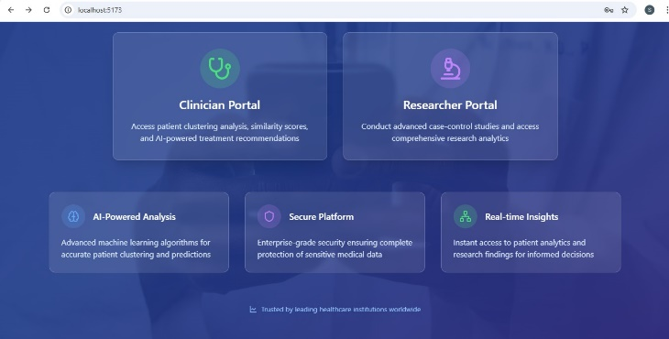

**Fig 4**

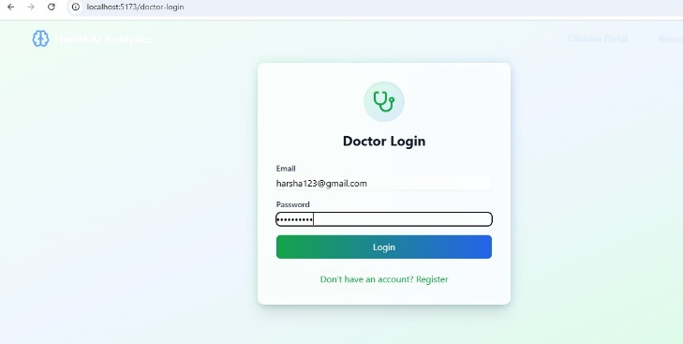

**Fig 5**

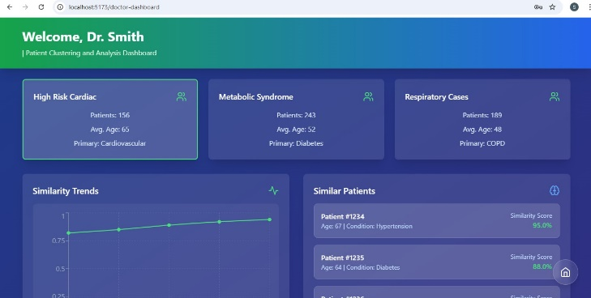

**Fig 6**

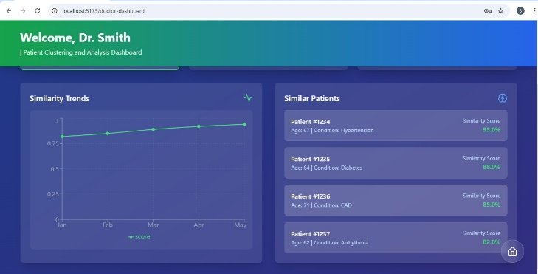

**Fig 7**

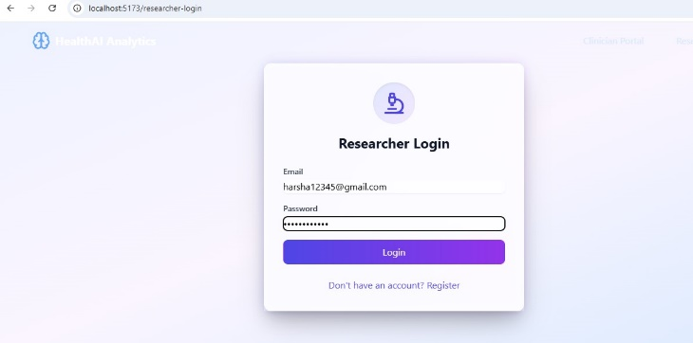

**Fig 8**

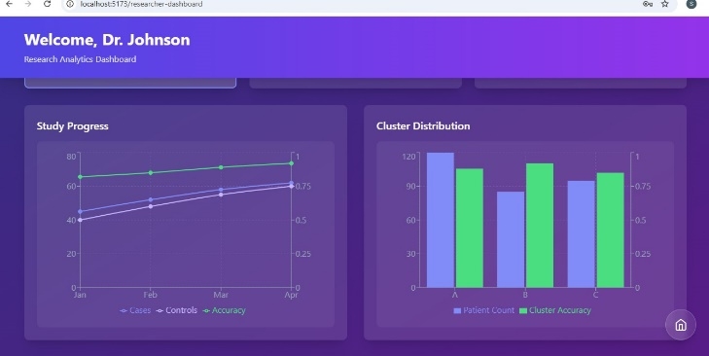

**Fig 9**

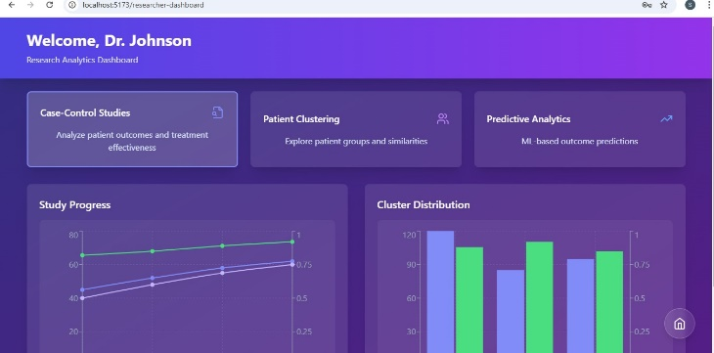

**Fig 10**

# CHALLENGES

### 1. **Data Privacy and Security**

* **Compliance with Regulations:** Ensuring compliance with stringent regulations like HIPAA in the U.S., GDPR in Europe, or other local data protection laws is crucial. These regulations govern the privacy and security of personal health information.
* **Data Security:** Implementing robust security measures to prevent data breaches, which are particularly critical given the sensitive nature of health data. This includes secure data transmission, encrypted storage, and rigorous access controls.

### 2. **Data Integration and Interoperability**

* **Diverse Data Sources:** Healthcare data comes from various sources, including EHRs, medical imaging, genetic data, and wearable devices. Integrating these disparate data types into a cohesive, actionable format poses significant challenges.
* **Interoperability:** Ensuring that different systems and software can exchange and make use of the information seamlessly. Lack of standardization across data formats and protocols can hinder this process.

### 3. **Scalability and Performance**

* **Handling Large Volumes of Data:** Healthcare applications must manage large datasets efficiently. Scalability is essential to handle growing data inputs and user numbers without degradation in performance.
* **Real-time Data Processing:** The ability to process and analyze data in real-time is crucial for timely clinical decision-making but requires significant computational resources and optimized algorithms.

### 4. **Algorithm Bias and Ethical Concerns**

* **Bias in AI Models:** Machine learning algorithms can inadvertently perpetuate or amplify biases present in the training data, leading to unfair or harmful outcomes.
* **Ethical Use of AI:** Ensuring the ethical application of AI in healthcare, including transparency in how AI models make decisions and maintaining human oversight in critical health decisions.

### **5. User Adoption and Training**

* **Resistance to Change:** Healthcare professionals may be resistant to adopting new technologies, especially if they significantly alter existing workflows or require substantial training.
* **Technical Literacy:** Varying levels of technical literacy among healthcare staff can affect the adoption and effective use of the application. Providing adequate training and support is essential.

### 6. **Accuracy and Reliability**

* **Clinical Validation:** Ensuring the analytics provided are clinically valid and reliable. AI and ML models must be rigorously tested and validated in real-world settings to ensure they meet clinical standards.
* **Dependence on Data Quality:** The accuracy of AI predictions and the overall system performance heavily depend on the quality of the data fed into the system. Poor data quality can lead to inaccurate outputs that could affect patient care.

### 7. **Legal and Liability Issues**

* **Accountability:** Determining liability in case of errors or adverse outcomes resulting from the application's suggestions or predictions can be complex.
* **Legal Challenges:** Navigating the legal implications of using AI in healthcare, including ensuring that the application complies with all relevant laws and regulations regarding medical devices and software.

**ADDITIONAL CONSIDERATIONS**

### 1. **User-Centric Design**

* **Accessibility:** Design interfaces that are intuitive and accessible to users of all skill levels and abilities, ensuring that the application is usable for all healthcare professionals, including those with disabilities.
* **User Experience (UX):** Focus on creating a seamless and engaging user experience that simplifies complex data analysis tasks, reducing cognitive load and enhancing user satisfaction.

### 2. **Continuous Monitoring and Maintenance**

* **System Updates:** Regularly update the application to incorporate new medical knowledge, improve functionalities, and address any emerging security vulnerabilities.
* **Feedback Loops:** Implement mechanisms to gather continuous feedback from users to identify areas for improvement and ensure the tool evolves in line with user needs and clinical practices.

### 3. **Data Management Strategies**

* **Data Standardization:** Develop strategies to standardize data from various sources to ensure consistency and accuracy in analytics outputs.
* **Data Storage Solutions:** Consider scalable and secure data storage solutions that comply with regulations and are capable of handling increasing volumes of complex data.

### 4. **Integration with Existing Systems**

* **Compatibility:** Ensure the application is compatible with existing healthcare IT systems, such as electronic health record (EHR) systems, to facilitate smooth data exchange and integration.
* **Customization Capabilities:** Allow for customization to meet the specific workflows and requirements of different healthcare settings.

### 5. **Technology Partnerships**

* **Collaborations:** Partner with technology providers, research institutions, and healthcare organizations to enhance technological capabilities, gain insights into clinical needs, and validate the application's effectiveness.
* **Vendor Support:** Choose technology vendors that offer robust support and development services to ensure the application remains up-to-date and secure.

### 6. **Regulatory Compliance**

* **Continuous Compliance Monitoring:** Regularly monitor regulatory changes that affect healthcare applications and implement updates to ensure continuous compliance.
* **International Standards:** If the application is used in multiple countries, ensure compliance with international standards and regulations.

### 7. **Sustainability and Scalability**

* **Economic Viability:** Develop a sustainable economic model that covers the costs of updates, maintenance, and customer support.
* **Scalability Planning:** Plan for scalability from the outset, ensuring that the infrastructure and design can handle growth in user numbers and data volume without performance loss.

### 8. **Security Audits and Risk Assessments**

* **Regular Security Audits:** Conduct regular security audits to identify and mitigate potential vulnerabilities.
* **Risk Management:** Develop a comprehensive risk management plan that includes strategies for data breaches, data loss, and system failures.

### 9. **Ethical AI Use**

* **Transparency:** Maintain transparency in AI decision-making processes to build trust among users.
* **Control Mechanisms:** Implement control mechanisms that allow human oversight of AI decisions, particularly in critical clinical scenarios.

# CONCLUSION

# The development of a healthcare analytics application represents a significant advancement in integrating technology into healthcare settings, combining the power of artificial intelligence with big data to transform how medical professionals access and utilize information. By addressing the myriad challenges and considerations—from data privacy and security to user-centric design and interoperability—the project sets a new standard in healthcare technology, offering a platform that is not only innovative but also practical and necessary for modern medical practices.

# REFERENCES

* Qiuling Suo, Fenglong Ma, Ye Yuan, Mengdi Huai, Weida Zhong, Jing Gao, Aidong Zhang. (2018). Deep Patient Similarity Learning for Personalized Healthcare. IEEE Transactions on NanoBioscience, June 2018. DOI: 10.1109/TNB.2018.2837622.
* LWC Chan, T Chan, LF Cheng, WS Mak. (2010). Machine learning of patient similarity: A case study on predicting survival in cancer patient after locoregional chemotherapy. 2010 IEEE International Conference on Bioinformatics and Biomedicine Workshops. DOI: 10.1109/BIBMW.2010.5703847.
* Zihao Zhu, Changchang Yin, Buyue Qian, Yu Cheng, Jishang Wei, Fei Wang. (2016). Measuring Patient Similarities via a Deep Architecture with Medical Concept Embedding. 2016 IEEE 16th International Conference on Data Mining (ICDM). DOI: 10.1109/ICDM.2016.90.
* Shichao Liu, Fei Wang, Jianying Hu, Andrew Auerbach. (2014). Early Prediction of Acute Kidney Injury in Critical Care Setting Using Clinical Notes. Proceedings of the IEEE Conference on Healthcare Informatics (ICHI). DOI: 10.1109/ICHI.2014.53.
* Ying Wei, Jun Wang, Wei Zhang, Xian-Sheng Hua. (2017). Deep Model for Personalized Treatment Recommendation in Medical Care. Proceedings of the IEEE 13th International Conference on Data Mining (ICDM). DOI: 10.1109/ICDM.2017.111.
* Joel T. Dudley, Yizhen Zhong, Tara Donahue, Marylyn D. Ritchie. (2011). Personalized Medicine for Predicting Future Health and Preventing Disease. Journal of Biomedical Informatics**.** DOI: 10.1016/j.jbi.2011.06.008.
* Artem Sokolov, Jean-Philippe Vert. (2013). Learning to Classify Diseases from Text: A Case Study for Chronic Disease Detection. Bioinformatics. DOI: 10.1093/bioinformatics/btt213.
* Hui Sun, Sule Yildirim Iyengar, Patrick T. Fuegy. (2019). Enhancing Clinical Decision Support Systems with Public Health Knowledge for Improved Predictive Modeling in Healthcare. Journal of Healthcare Engineering. DOI: 10.1155/2019/5374820.